In this session we will see following topics

1. Create REST API / Web service with Spring.
2. REST concepts, json and HTTP messaging.
3. Install REST client tool: Postman
4. Develop WEBService/REST API using @RestController
5. Build CRUD interface to database with spring REST.

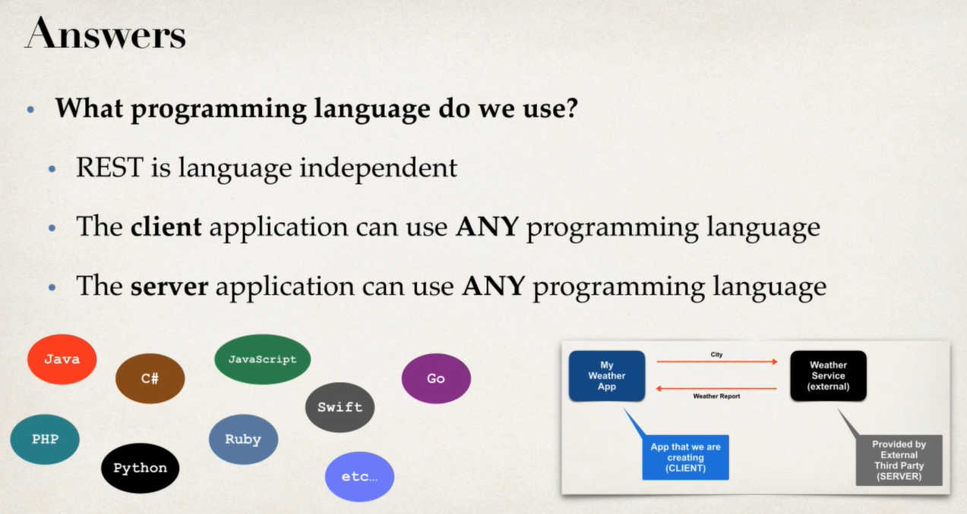

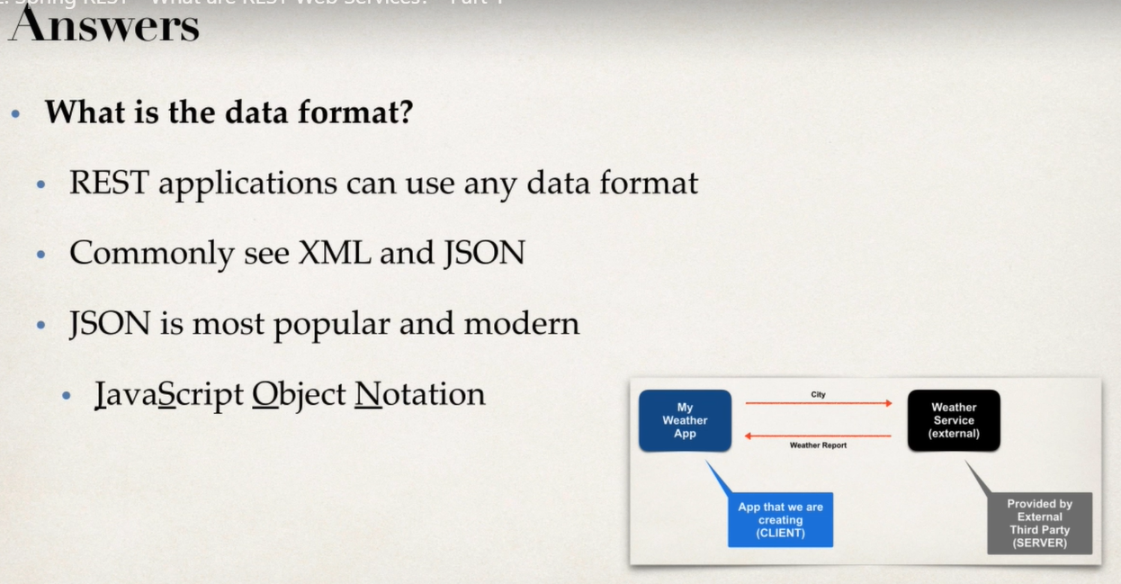

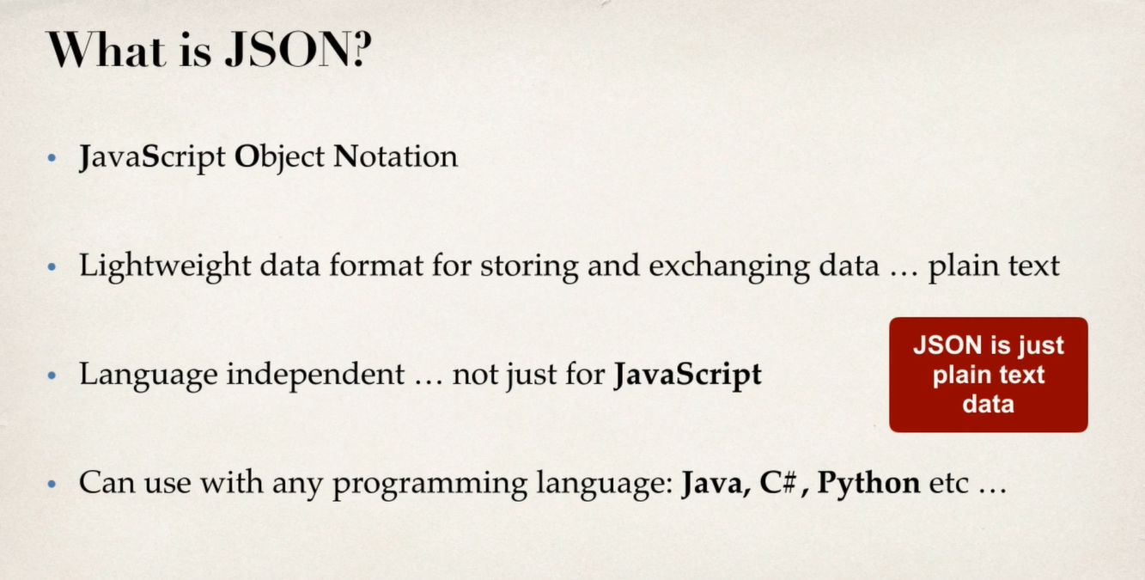

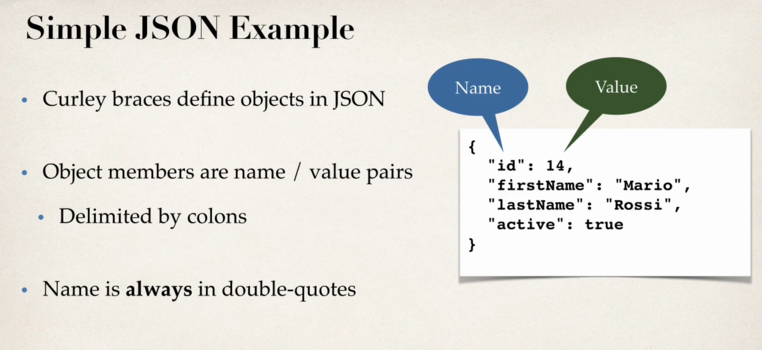

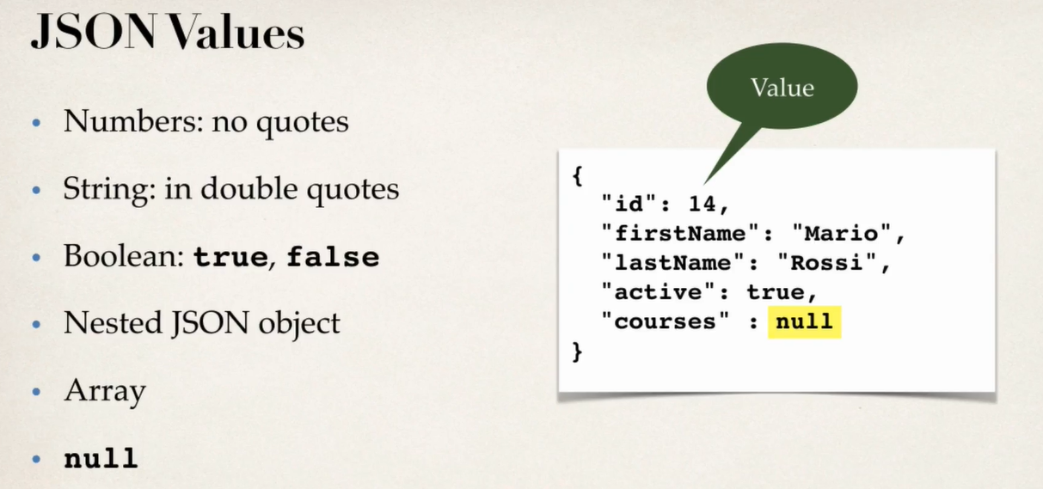

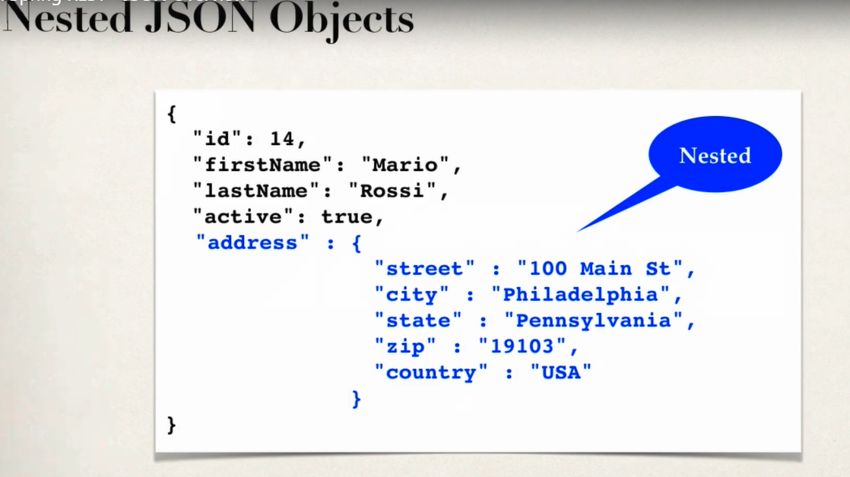

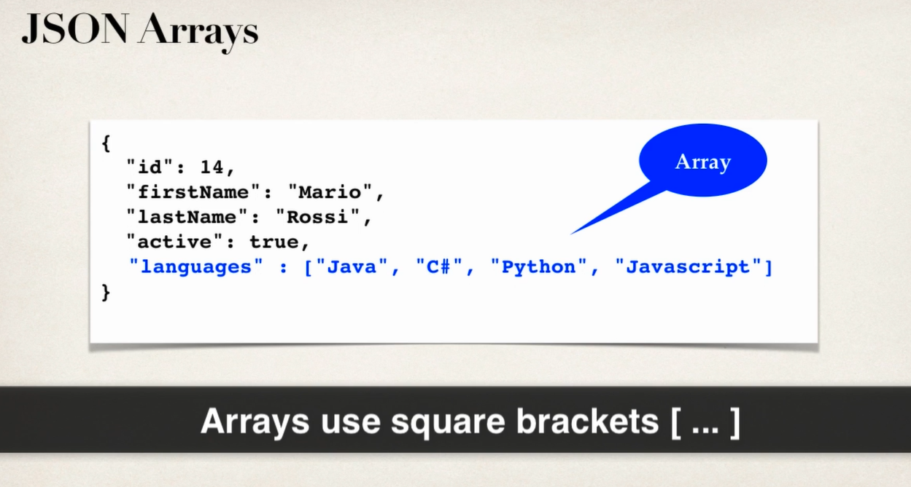

Add notes from photos in phone.

REST over HTTP

1. most commonly we use REST over http protocol

2. use HTTP methods for CRUD operations.

Http Methods CRUD Operations

POST create new entity

GET Read list or single entity

PUT Update existing entity

DELETE Delete excisting entity.

Http Messages

Client

http request message

CRM Rest Service

MyCRM app

http response message

What’s in request message

Http request Message will contain

1. Request line -- > it wil contain method like GET, POST, PUT, DELETE
2. Header Variables 🡪request Metadata, like browser info, url, location
3. Message Body🡪contents of message body.

What’s in response message

Http request Message will contain

1. Response line -- > it will contain server protocol and status code.
2. Header Variables 🡪send metadata like content type – like xml, html, json also size and length of data.
3. Message Body🡪contents of message body. Example if we want to get customer details then those details will be sent in message body.

Http Status Code:

Code Range Description

100-199 Represent information

200-299 Represent success

300-399 Represent Redirection information

400-499 Represent Client error

500-599 Represent Server error

Some examples are:

401- Authentication required.

404 – File not found.

500 – internal server error

Mime Content type

The message type of message in message body is defined by using Mime type

MIME- Multipurpose Internet Mail Extension

Syntax 🡪 type/sub-type

Ex: text/html, text/plain

And for REST full clients we will have to use

Application/json, application/xml

We need client tool

This tool is use to send http request to web service /API and get response

So there are lots of tools available in market for same but here we will use curl, POSTMAN

<https://jsonplaceholder.typicode.com/users>

Spring REST support

Spring WEB-MVC provides support for spring REST

So we will see new annotation by @RestController

It is nothing but extension to @Controller

It handles REST requests and responses.

Spring REST will also capable of converting java POJO to json.

As long as Jackson project is on classpath or in pom.xml

Let’s demonstrate it with simple example

We will write code here for service

REST Client

/test/hello

REST Service

HelloWorld

Client can use web browser or postman

Here we may have question that web browser and postman are same?

Yes they are similar but for testing our webservice we can use Postman in order to test or http methods.

In some cases we may get exception,

1. If data won’t be available with respective request
2. If request will be of bad type

@ExcptionHandler

What is a ResponseEntity?

ResponseEntity **represents an HTTP response, including headers, body, and status**. While @ResponseBody puts the return value into the body of the response, ResponseEntity also allows us to add headers and status code.